A test plan was not available for 3284 test plan 7840 was used instead. The Black box test plan provided by 7840 provide a total of 5 test the last 2 of which could not be run. Tests 1 and 2 function as acceptance tests by testing that the code can sort a NxN table that is either sorted or unsorted. Test 3 and 4 covered unacceptable input by testing the code using a non NxN table and a NxN table that contains doubles. The last test asks for a table containing a total of 2,147,302,921 values to be created in order to test the boundaries of the code. The last test would have to be automated in order to conduct it in a feasible manner. Acceptable input tests could have included an empty table test case. Unacceptable input tests could include a test case where the values exceed the size of the table by one. Both of these would help with boundary testing.

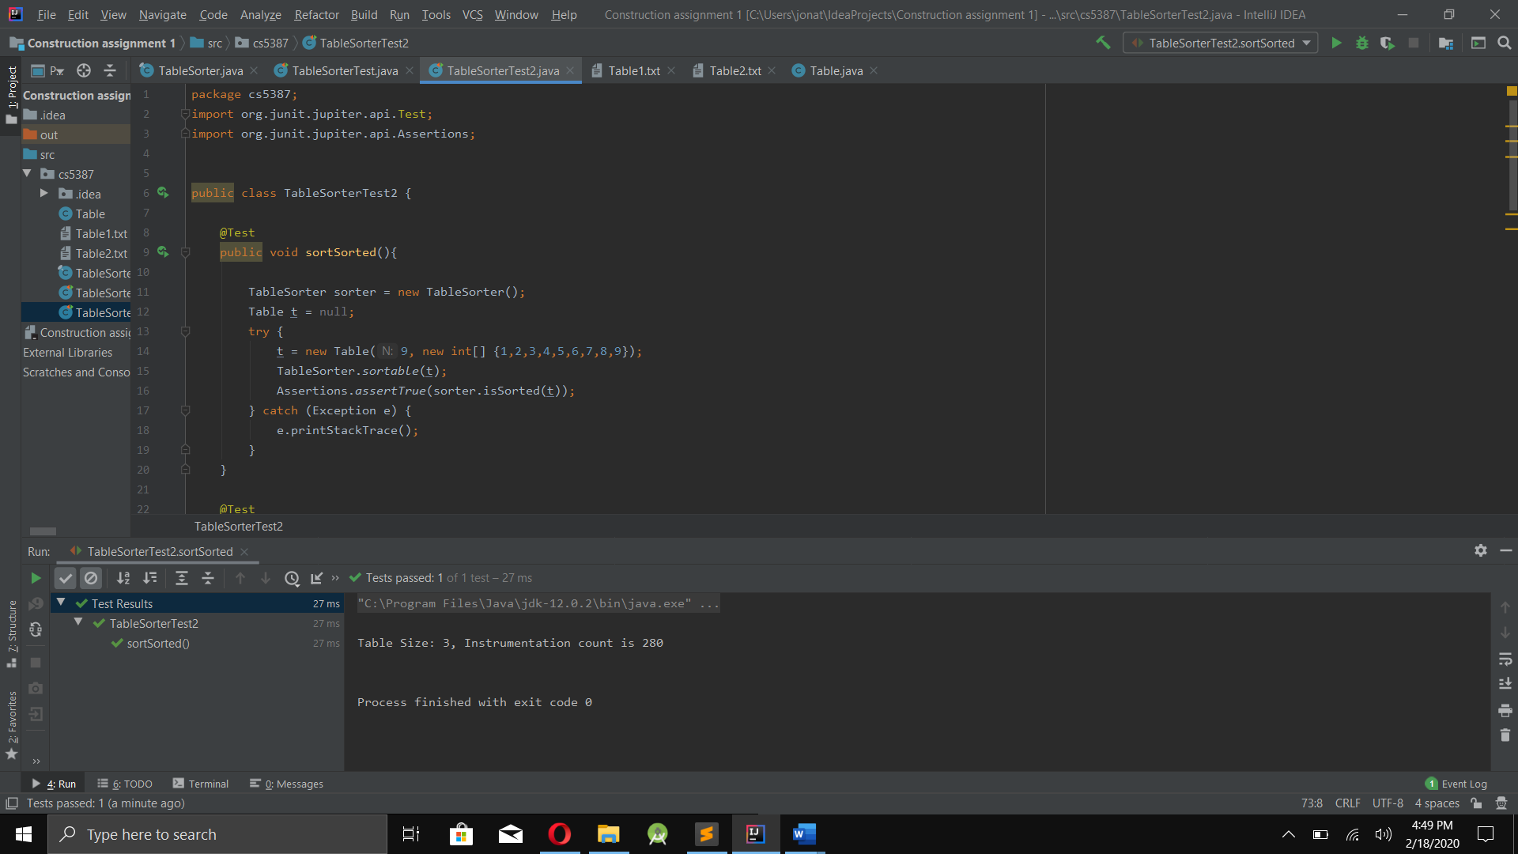Test1:

Test 2:

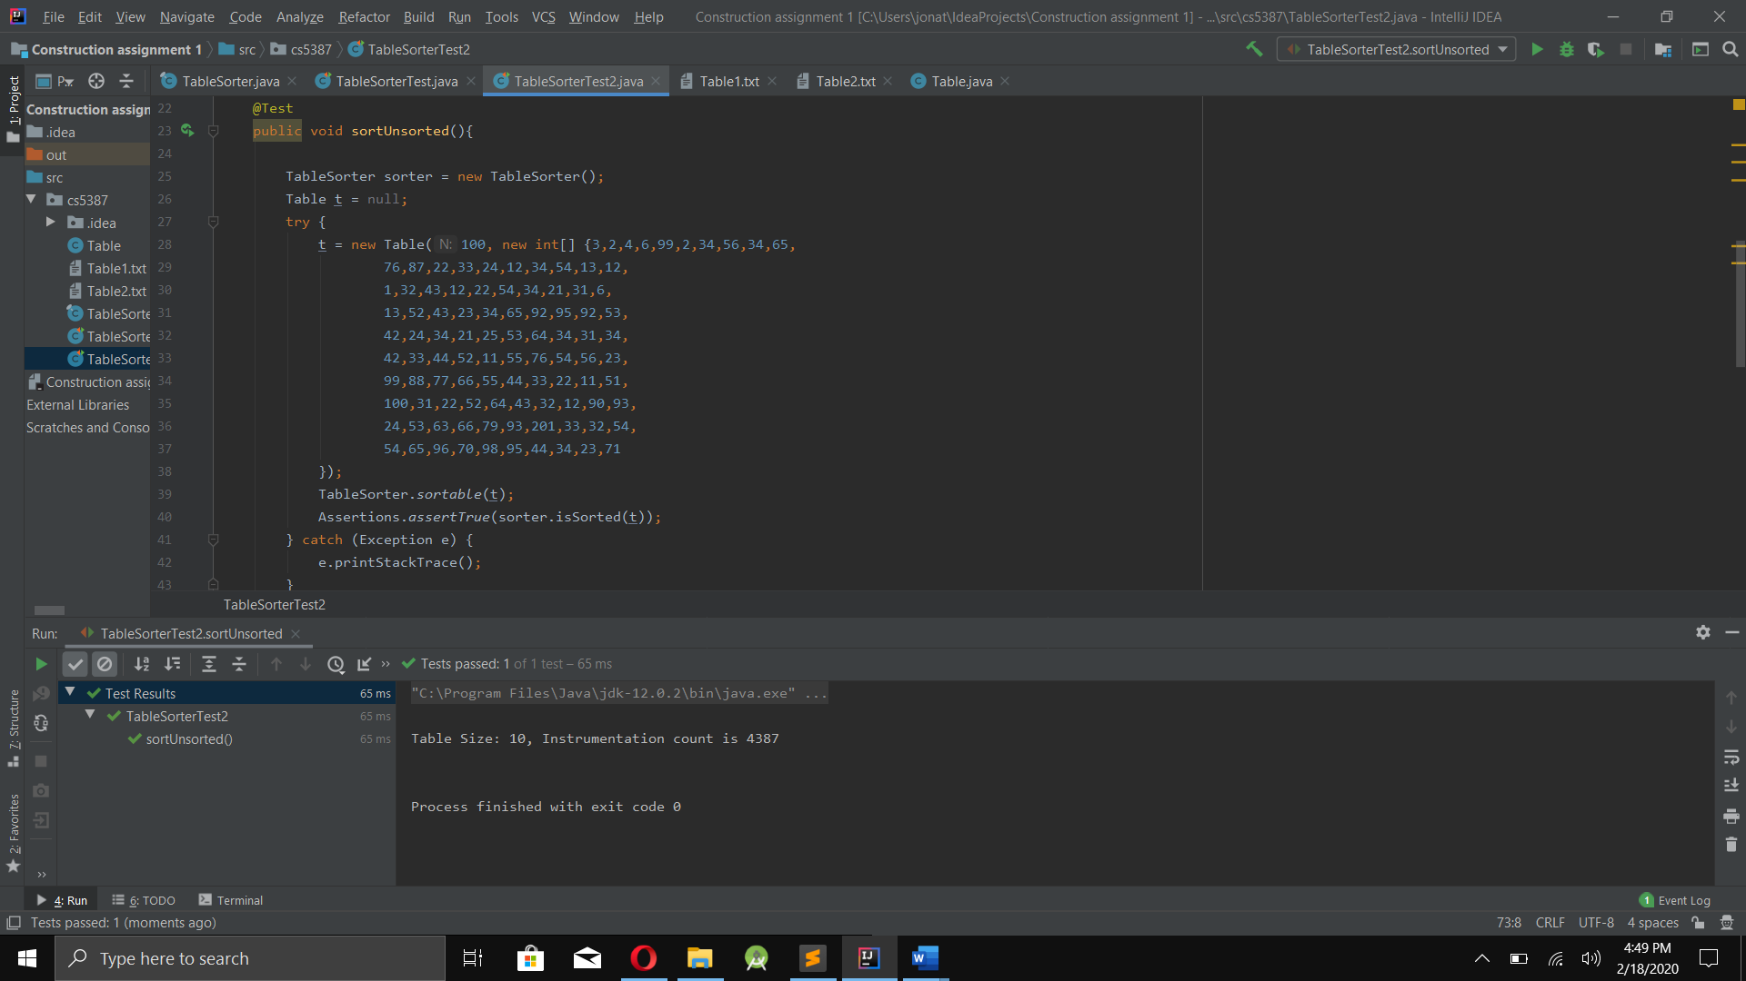

Test 3:

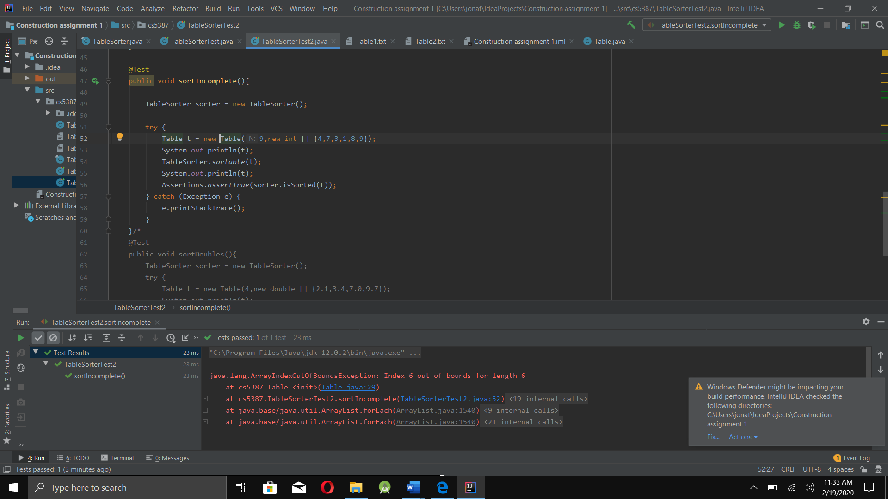

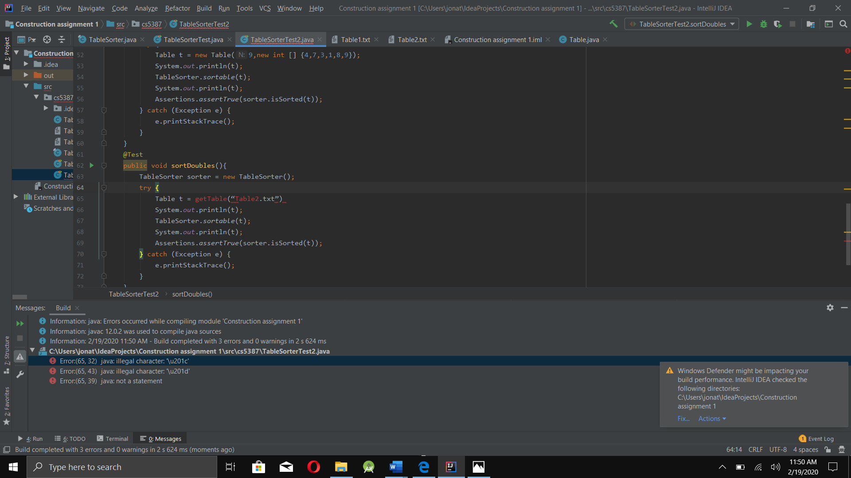Test 4: